Hi Mangusn

Abeans.com already had a domain registered. A micro-investing and savings platform

Abeans are very similar to acorns.com, raiz.com.au, raiz.com.my

Web app would be great because most people will use their mobile. There are no integration yet except the contact, sign up form but we redirect to a form that “We are currently building features and will be ready soon”

Basically, we need a good landing page for an illustration of Abeans products and services. Below are some wireframes and markup but we can design a few more graphics to complement the features like Acorns.com theme be perfect

Thanks, advance bro for your help and hope to see you soon in Thailand.



We’re changing the way Thais save & invest every day
SAWADEE TO ABEANS

Save, invest, and
learn from one easy app!
Invest spare change and earn bonus investments automatically from everyday purchases into a diversified portfolio.

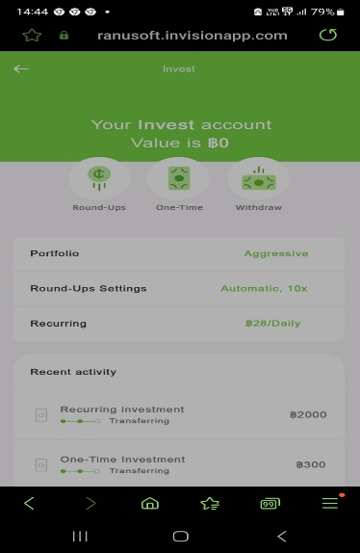

Round-Ups

Automatically save and invest with the Roundups feature
Every purchase you make means an opportunity to invest your spare change! So coffee for B0.75 becomes a B0.25 investment in your future.

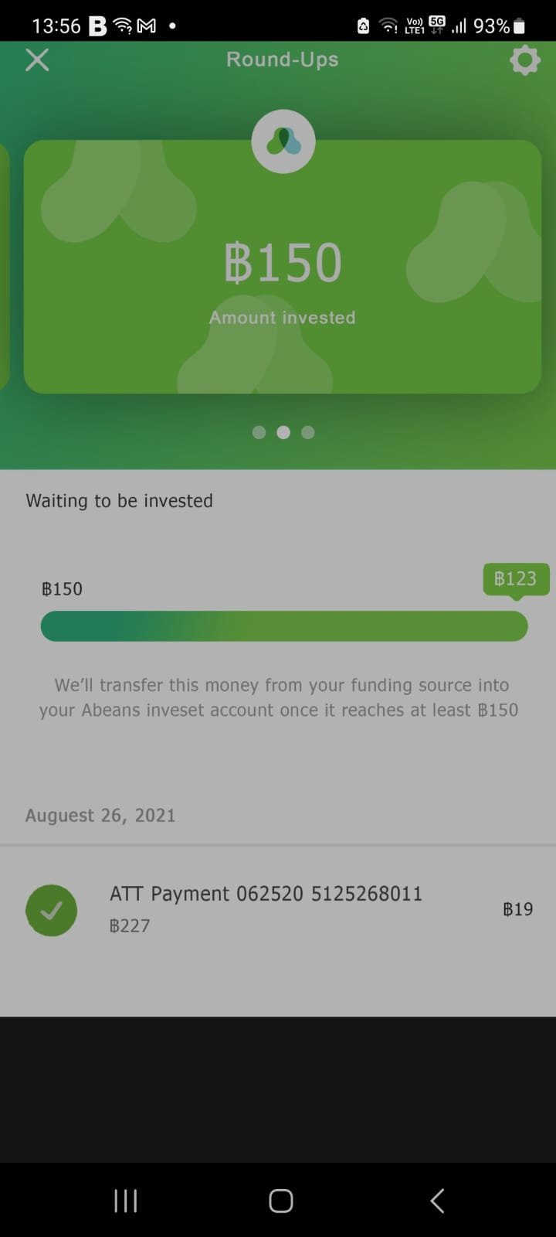

Abeans Rewards
Shop through Abeans Rewards and we’ll invest bonus cash back into your account. It’s automatic savings across hundreds of your favorite brands.




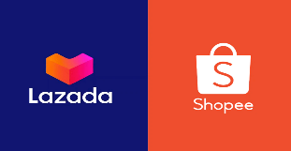

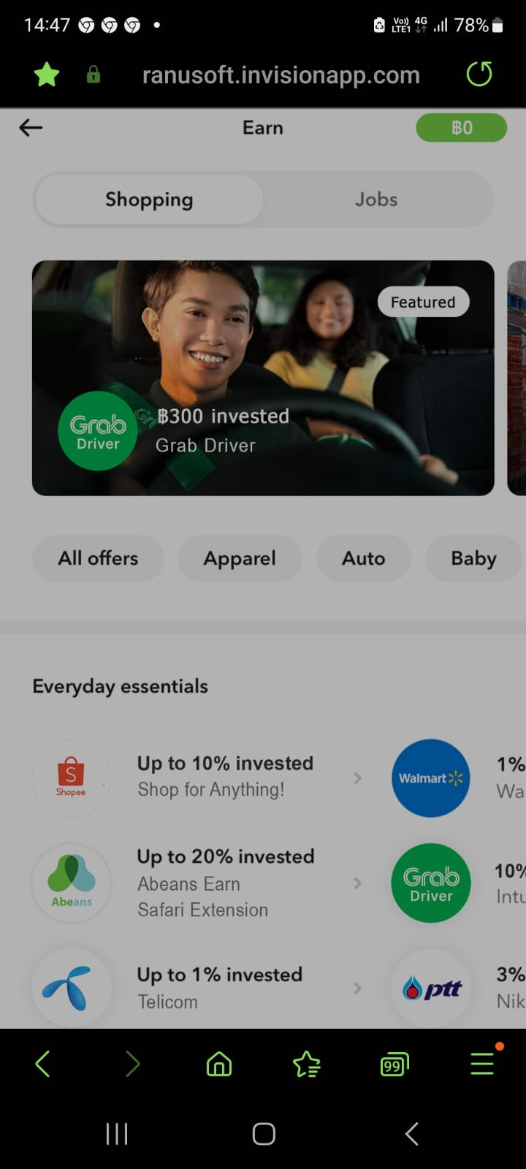

How does Abeans invest work?
Abeans works by allowing you to invest small amounts of money in a diversified portfolio of assets. Abeans is best known for its Round-Up feature which involves rounding up your transactions to the nearest dollar and investing the spare change into your Abeans account. This means that for every purchase that you make, you are also investing in your Abeans portfolio.
What is Round-Up?
A “round-up” is the virtual spare change captured from rounding up a transaction to the nearest dollar. When you link a credit or debit card to your Abeans account, we track the spare change from your transactions and make it available for you to invest. Your roundups will be viewable in the app. Simply choose which ones you would like to invest in or change your settings to automatically invest round-ups after each purchase.
How do I choose an investment portfolio?
Abeans offers you the choice of 3-4 portfolios, ranging from conservative (least risky) to aggressive (most risky), along with the Crypto ETFs portfolio (Bitcoin holding), and the Custom portfolio. These portfolios have different risk profiles and accordingly have different expected returns.
Recurring Investments - Set & forget recurring daily, weekly, or monthly investment top-ups.
Lump Sum - Make one-off investments to boost your Abeans account as often as you’d like - brokerage free
What is Abeans rewards?
Abeans Rewards is our loyalty program. When you shop with our partner brands through Abeans Rewards, they will invest a dollar amount or % of your purchase price back into your Abeans account. Abeans may also be paid a fixed amount or % of your purchase price for promoting the partner brand.

Secured Payments
Encrypting processes, and
store card data securely

As a PCI DSS Service Provider Level 1, we encrypt process, and store card data. Our payment platform allows consumers to pay merchants within the most secure environment.check icon
Compliance with PCI-DSS Level 1 requirements check icon

Protect data and prevent fraud check icon

Compliant with international standards for AML and KYC

